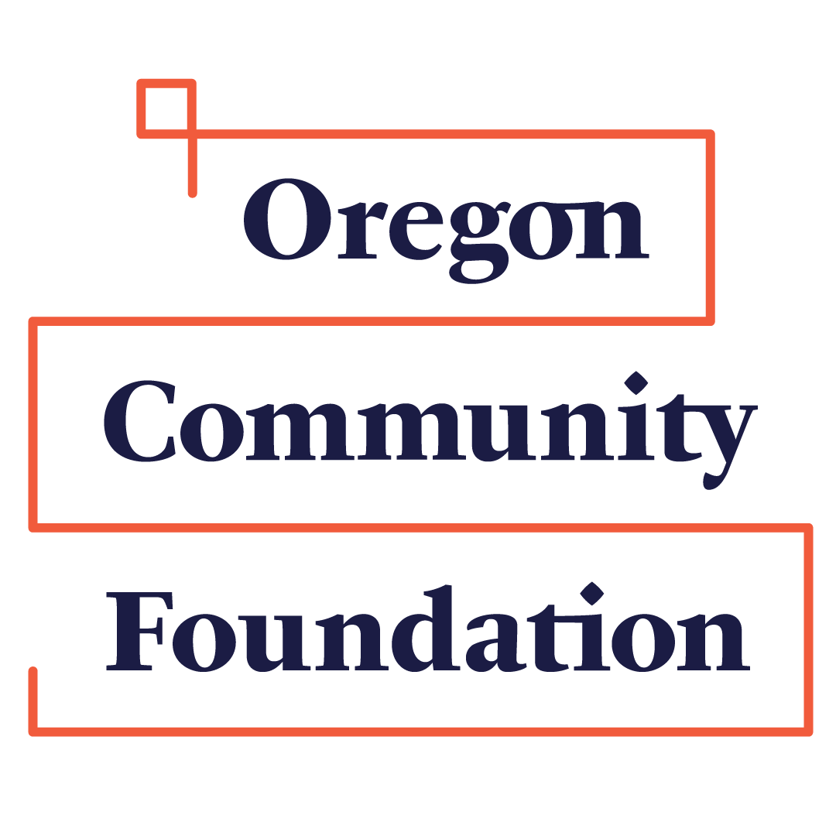Grant Evaluation Form
Oregon Natural Resources Education Fund (ONREF)

Please submit within 30 days of completing Funded Project

Please check for received funds: | ONREF General Fund Request |  | Terry Selby Sub-fund Request |  | Oregon Small Woodlands Association Subfund Request
 | Pleasant Hill  Sub-fund Request |  | OSAF Sub-fund Request

Date:
Organization Name
Contact Name
Address
City |  |  |  |  | State |  |  |  |  |  | Zipcode
District |  |  |  |  | E-Mail
Phone # |  |  |  |  | Fax #
Project Description
of what funding was used for, actual results to date. Including measurable outcomes and specific objectives reached.
Sometimes the positive impact of a project is not easy to communicate via measurable results. Please share with us a brief story that illustrates the effect the project has had.

How many persons benefited from the funding received?
Has the grant (1) helped to attract new partners from the community, (2) increased collaboration with other organizations, (3) increased student involvement in the program? How has your program changed as a result of this project?
What type of recognition outreach did your organization provide for funders, such as ONREF? |  | Note: It is strongly encouraged that in addition to this report, any additional media such as photographs, videos, news articles or student work may be submitted to the ONREF Board. Please have parental release for all minors photographed.
Final Project Budget |  | Total project budget |  |  |  |  | $ |  |  | Total received from ONREF |  |  | $
Itemized Budget of Project
 |  |  | $ |  |  |  |  |  |  |  |  |  |  | $
 |  |  | $ |  |  |  |  |  |  |  |  |  |  | $
 |  |  | $ |  |  |  |  |  |  |  |  |  |  | $
 |  |  | $ |  |  |  |  |  |  |  |  |  |  | $
 |  |  | $ |  |  |  |  |  |  |  |  |  |  | $
 |  |  | $ |  |  |  |  |  |  |  |  |  |  | $
How was ONREF funds utilized (provide detailed amounts if applicable)
 |  |  | $ |  |  |  |  |  |  |  |  |  |  | $
 |  |  | $ |  |  |  |  |  |  |  |  |  |  | $
 |  |  | $ |  |  |  |  |  |  |  |  |  |  | $
 |  |  | $ |  |  |  |  |  |  |  |  |  |  | $

Name (printed) of grantee |  | Title
Signature of grantee |  | Date

Thank you for your partnership with Oregon Natural Resources Education Fund.
Send report electronically to:
jennifer@starkerforests.com

